# Task C10.2.1

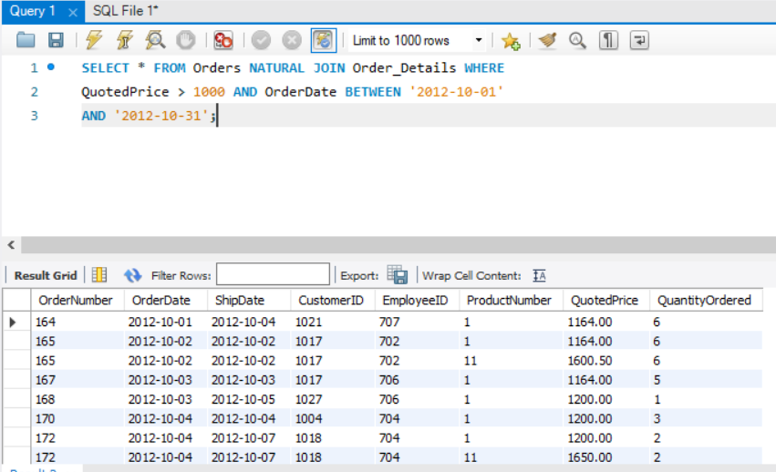

Figure 2 SELECT query without EXPLAIN EXTENDED

**Running SELECT query without prefixing EXPLAIN EXPANDED:** Yes this is what I was expecting from given query as in this query we are first doing NATURE JOIN which joins tables with same column names in our case that column is OrderNumber and that’s why it has joined rows in both tables with having same values for OrderNumber field.

Other Conditions are also fulfilled in this output as for each row quoted price is more than 1000 and order date is between 2012-10-01 and 2012-10-31.

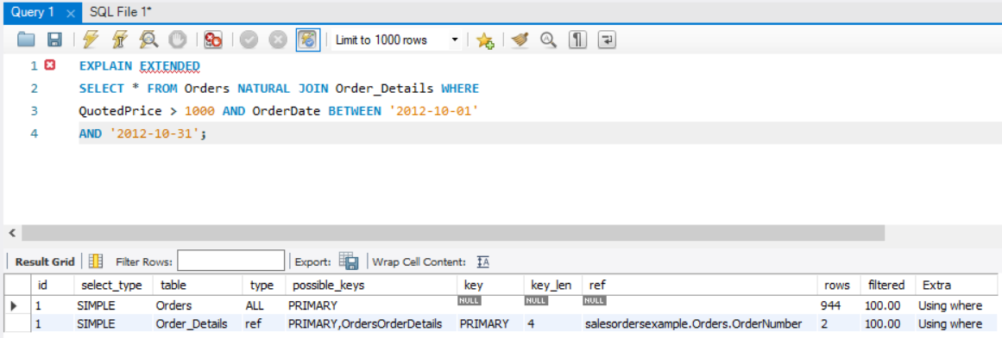

Figure with Explain Extended

**Running query with EXPLAIN EXPANDED prefix:** form above output it is clearly seen that database engine is going through every row in orders table first and than matching it with index in Order_Details table in this case index is Primary key in both tables. Select_type is UNION.

Length of key used to join table is 4 which happens to be a primary key.

Here data base is examining 100 percent rows in both table according to WHERE clause which is computationally very expansive.

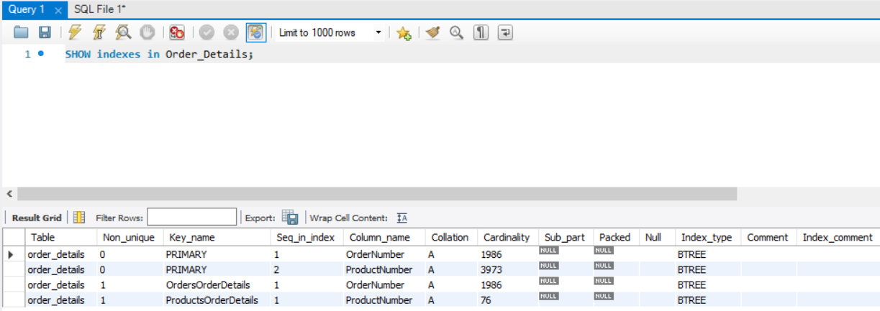

Figure SHOW indexes

Currently there are four indexes associated with order_Details table with two columns relative to Orders and Product tables.